CIVIL COURT OF THE CITY OF NEW YORK
COUNTY OF KINGS: HOUSING PART B
CHRISTIAN GRAY,  Tenant-Petitioner,  -against-  AMERICAN PACKAGE COMPANY, INC.,  Owner-Respondent,  -and-  THE DEPARTMENT OF HOUSING PRESERVATION AND DEVELOPMENT,  Respondent. | Index No. HP 6086/2020  STIPULATION OF SETTLEMENT  SO-ORDERED  __________________________ J.H.C.

IT IS HEREBY STIPULATED AND AGREED, by the Petitioner, Christian Gray (“Petitioner”) and Owner-Respondent, American Package Company, Inc. (“Respondent”) (collectively, the “Parties”) and their undersigned counsel, that this proceeding is settled upon the following representations, promises, terms and conditions:
Without admitting any wrongdoing, fault, or any of the allegations set forth in Petitioner’s Verified Petition, dated June 29, 2020 (“Petition”), Respondent has retained a licensed and insured mold remediation named Serve Pro (emergency contact is Lisa Mulcahy whose email address is lmulcahy@servprohoboken.com and cell phone # 551-226-1997) company (“Mold Remediation Company”) to perform the scope of work annexed hereto as Exhibit 1 (“Remediation Work”) in apartment G21 (“Apartment”) in the building located and known as 97 Green Street, Brooklyn, New York 11222 (“Building”).
- The Remediation Work shall commence on July 20, 2021 with regard to the preparation work with the remediation work to commence on July 21, 2021 (“Renovation Work Commencement Date”). The remediation company will file the Post Remediation Assessment form and Mold Remediation Certification as required by NYC EPA.
- Respondent shall have unfettered access to the Apartment until all the Remediation Work is completed.
- Respondent’s mold inspection company, ALC Environmental (“ALC”) and Petitioner’s mold inspection company, Olmstead Environmental Services (“Olmstead”) shall be permitted to be present during the Remediation Work. Petitioner and Olmstead shall not interfere with the Remediation Work. Petitioner and Respondent landlord shall not be present during the Remediation Work.
- Upon completion of the Remediation Work (“Completion Date”), ALC shall inspect and test the Apartment to ensure that the Remediation Work has been completed and prepare a written report (“ALC Post Remediation Report”). Respondent’s counsel shall provide Petitioner’s counsel with a copy of the ALC Post Remediation Report by e-mail at mbs@goodfarblaw.com.
- Within 5 days (“Olmstead Inspection Deadline”) of Respondent’s counsel delivering a copy of the ALC Post Remediation Report to Petitioner’s counsel, Olmstead shall inspect and test the Apartment to ensure that the Remediation Work has been completed and prepare a written report (“Olmstead Post Remediation Report”). Petitioner’s counsel shall provide Respondent’s counsel with a copy of the Olmstead Post Remediation Report by email at DSkaller@bbgllp.com within 14 days of the Olmstead Inspection Deadline. In the event Olmstead fails to inspect and test the Apartment by the Olmstead Inspection Deadline, Petitioner shall forfeit and waive its right to inspect and test the Apartment and shall not be permitted to restore this proceeding or commence a proceeding or action to challenge ALC’s report or that the Remediation Work has not been completed.
- In the event that ALC and Olmstead agree that the Remediation Work is completed after the Completion Date (“Completion Confirmation Date”), this proceeding shall be discontinued and the Parties shall forthwith execute and file a stipulation of discontinuance, with prejudice.
- In the event ALC and Olmstead cannot agree that the Remediation Work has been completed or additional remediation work is necessary, either party may restore this proceeding, by notice of motion, for a hearing on the sole issue of whether the Respondent did not comply with the agreed upon Remediation Work or any additional work that either or both ALC and Olmstead believes should have been performed as being necessary and in such case the court will hold a hearing to determine if the additional disputed work is necessary. In the event Petitioner establishes that the Remediation Work or additional disputed work was not completed, the Court shall issue an order or Respondent will agree to perform the outstanding Remediation Work to be completed. In the event Respondent establishes that the Remediation Work was completed, this proceeding shall be dismissed, with prejudice. The prevailing party shall be entitled to an award of attorneys fees with regard to fees incurred after the Completion Date.
- In the event ALC and Olmstead agree that the Remediation Work was not completed after the Completion Date, the Mold Remediation Company shall complete the agreed upon outstanding Renovation Work and the Parties shall repeat the process as stated in paragraphs five (5) through nine (9) herein.
- The Parties represent and acknowledge that this proceeding may only be restored for purposes of enforcing compliance with either Parties’ obligations stated in this Stipulation regarding the Remediation Work or for additional disputed work.
- For the valuable consideration set forth above and with the exception of the rights and obligations arising pursuant to this Stipulation, this Stipulation shall constitute the parties’ accord and satisfaction and mutual release of any and all demands, rights, claims, remedies, actions, causes of actions or liabilities (collectively referred to herein as “claims”) that any party hereto may have against any other party hereto or against representatives, heirs, successors, assigns, officers, directors, partners, agents, or employees of the other contained in Petition from the beginning of the world through the date of this Stipulation.
- Both parties reserve their claims and defenses with respect to attorneys fees and cost incurred by the respective parties.
- It is specifically understood and agreed by and between the parties that the within Stipulation is the result of extensive negotiations between the parties and that both parties shall be deemed to have drawn these documents in order to avoid any negative inference by any court as against the preparer of the document.
- This Stipulation supersedes and revokes all previous negotiations, arrangements, letters of intent, representations, and information conveyed, whether oral or in writing, between Petitioner and Respondent or their respective representatives or any other person purporting to represent Petitioner and Respondent pertaining to this proceeding. All prior statements, understandings or memoranda shall be merged into the terms of this Stipulation and shall not survive. Except as otherwise provided in this Stipulation, no subsequent alteration, amendment, change or addition to this Stipulation shall be binding upon Petitioner and Respondent, unless in writing and signed by the party against whom enforcement of the alteration, amendment, change or addition is sought.
- This Stipulation is entered into after full investigation. Neither party has relied upon any statement or representation not specifically embodied in this Stipulation. Each party has had the opportunity to retain counsel and review this document with a counsel of their choosing.
- This Stipulation shall be binding upon the respective parties, their heirs, assigns, executors, administrators and successors-in-interest to their property.
- Facsimile, electronic or PDF signatures shall be deemed originals.
- This Stipulation may be executed in one or more counterparts, each of which shall be deemed an original, but all of which together shall constitute one and the same instrument.
BELKIN BURDEN GOLDMAN, LLP  Attorneys for Owner-Respondent  270 Madison Avenue  New York, New York 10016  (212) 867-4466  By:______________________________  David M. Skaller, Esq.  Department of housing preservation and development  100 Gold Street, 6th Floor  New York, New York 10038  By:______________________________  Anne M. Broomfield, Esq. | Goodfarb & Sandercock, LLP  Attorneys for Petitioner  110 E 59th Street, 22nd Floor  New York, New York 10022  (212) 509-0440  By:______________________________  Margaret Sandercock, Esq.  Petitioner  By:_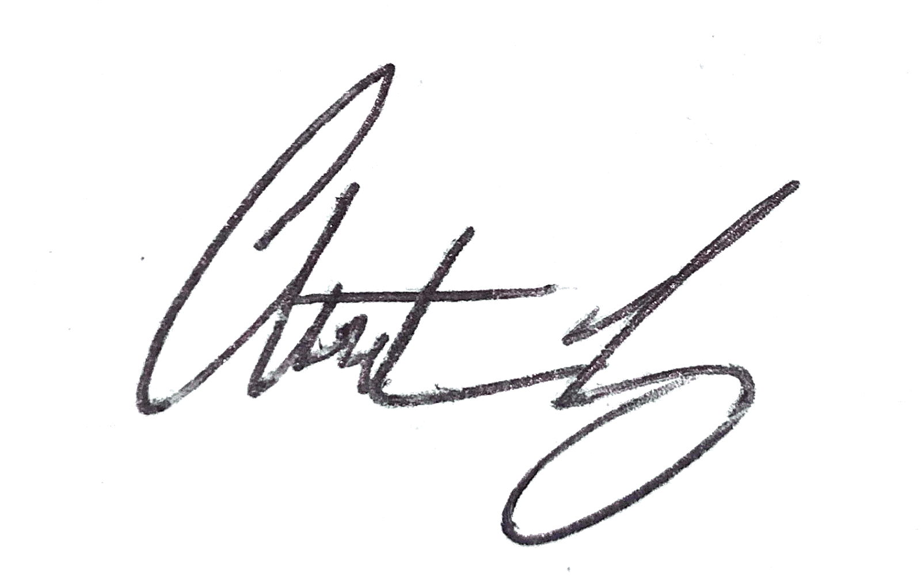_____________________________  Christian Gray

